WINE FUNDRAISER

Marist Football Club and Hay Shed Hill wines are working together to raise funds towards the new electronic scoreboard.

The wines on offer are current release, premium Margaret River Wines by Hay Shed Hill and are offered to the Club at a discounted rate, plus a donation for every dozen sold will be given to the club.
HAY SHED HILL WILL DONATE $30-$40 FOR EVERY DOZEN SOLD

HAY SHED HILL VINEYARD SERIES WINES | RRP  PER DOZEN | SPECIAL OFFER  PER DOZEN | Qty | Amount
Hay Shed Hill Sparkling Pinot Noir Chardonnay | $360 | $288
Hay Shed Hill Chardonnay | $336 | $288
Hay Shed Hill Pinot Noir Rosé | $264 | $210
Hay Shed Hill Shiraz Tempranillo | $264 | $210
Hay Shed Hill Cabernet Sauvignon | $336 | $288
PITCHFORK WINES
Pitchfork Semillon Sauvignon Blanc | $204 | $168
Pitchfork Pink (Rosé) | $204 | $168
NV Pitchfork Moscato | $204 | $168
Pitchfork Cabernet Merlot | $204 | $168
Pitchfork Shiraz | $204 | $168
This exclusive pricing does not allow us to offer mixed cases. however, as most wines are  packed into 6 bottle cartons we can ACCEPT a split case as long as the split is 6 bottles of each Totals  variety. MINIMUM ORDER QTY is 12 BOTTLES. |  |  | Qty | $

PLEASE COMPLETE ALL DETAILS BELOW IN CLEAR PRINT
Name: * Address:*
State: Post Code:

Contact number:* Email: *

MasterCard Visa Card Number: * Expiry: * / CCV: *

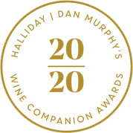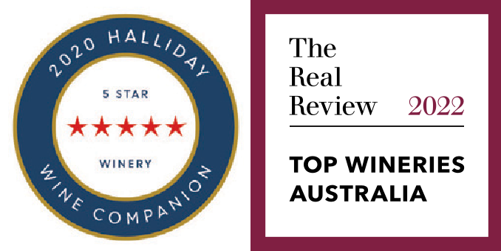Name on Card: * SIGNATURE:*
HOW TO ORDER:
Email your order to: Joe Baily
sponsorship@maristfc.com.au

Joe: 0401 368 005
By providing your contact details you subscribe to receive future special offers, promotions plus information about special events from Hay Shed Hill and Kerrigan+Berry, and from our agents, until such time as you request us to stop. Should you wish to opt out at any time simply let us know by phone or email. We will provide you with approrpriate contact details every time we contact you. Your details remain yours and may only be shared with our agents for the purposes of communicating Hay Shed Hill and Kerrigan+Berry offers only. They will NOT be sold or rented to any other companies.

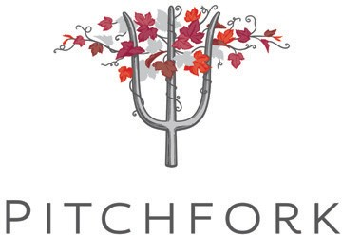
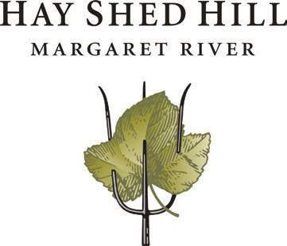
I declare I am 18 year of age or older (signature):

Wine Companion 2020 Awards 10 of the Best Value Wineries Hay Shed Hill Wines

